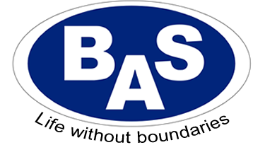
BAS (NW) Ltd
School Lane
Hollins Green
Warrington
WA3 6LJ
Tel: 0161 776 1594 / 01925 640730
Email: office@basnw.co.uk
Website: www.basnw.co.uk
Company Registration No: 8353221
__________________________________________________________________________________
Name:
Products Supplied/Fitted:

Please can you complete the VAT exemption form below for the products supplied/fitted by BAS (NW) Ltd. Please sign and return either via email or by post.

Thank you.

VAT EXEMPTION
I declare that I am chronically sick or disabled by reason of …………………………………………… of Schedule 8 of the Value Added Tax Act 1994

Signed ……………..……………….………….. PRINT NAME ……………………………………………………….
Date ………………………………………………….
I also declare that the supply of goods and/or services specified above, are eligible for relief from VAT under Group 12

