Manual Transfer Plate Fitting Instructions www.basnw.co.uk
Office: 0161 776 1594
Technical: 07789 000424
Email: office@basnw.co.uk

Please read fitting instructions before starting assembly.
Please check all components are correct. See below.
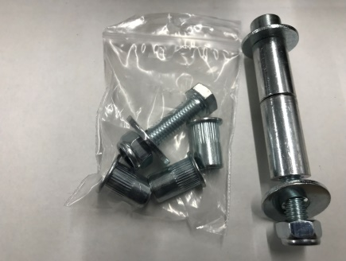
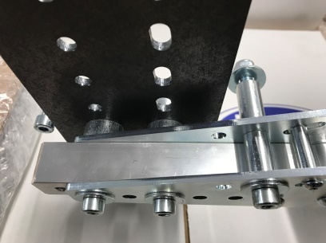
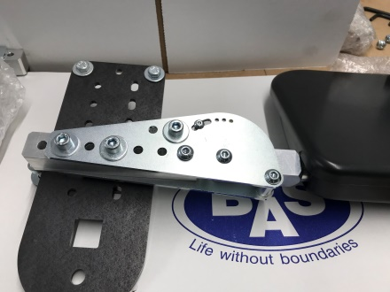
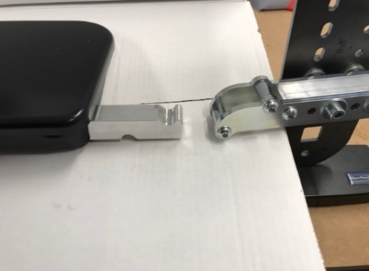
Folding
Removable

Check you have sufficient space between the Seat and the “B” pillar for the Manual transfer plate to be fitted without it causing an obstruction. If room is limited, you could permanently remove all or part of the “B” pillar trim and replace with a leatherette type material suspended between the front and rear door seals on the pillar.
Although this is a universal product we have provide a mounting plate with many choices of location for the main supporting bracket for the transfer plate, so you can find the ideal height required for your customer. See below.
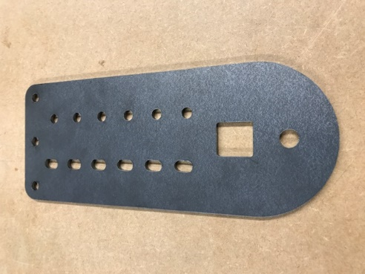

PLEASE NOTE the elongated holes in the mounting plate MUST be nearest to the front of the vehicle. See below. THE PLATE MUST BE MOUNTED VERTICALLY.
Elongated Holes.

You can cut, bend, drill or add brackets to this plate to assist in fitting, we have provided extra fitting options and spacers if required to assist in passing the seat belt between the bracket and “B” pillar. These can be cut to your required size. See below.
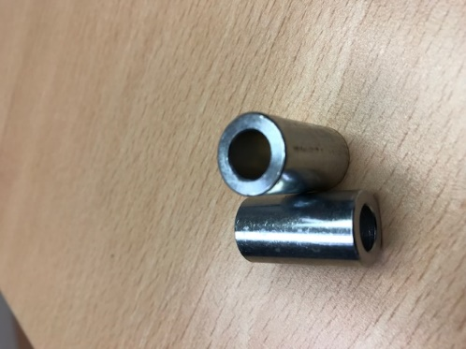

You will also notice a hole, bottom centre of the mounting plate. This may be able to be used on the seatbelt reel mounting bolt, either directly or if you manufacture an extension plate. There is also a threaded hole that can be used as additional fixing in the supporting bracket mounting plate. PLEASE NOTE this threaded bracket can be fitted with the additional threaded hole to the front or rear. See below.
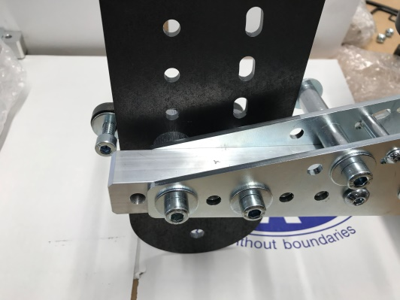
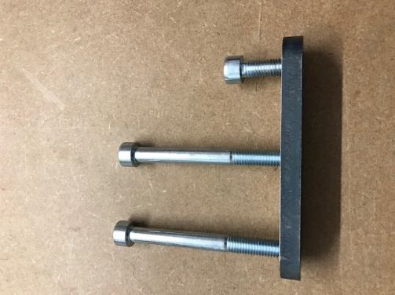
Extra fixing point.

When attaching the supporting bracket to the mounting plate you will see you have been supplied with 6 spacers. These spacers can be mounted in any configuration to suit your requirements or just a selection either side of the supporting bracket or not at all if not required. See below.

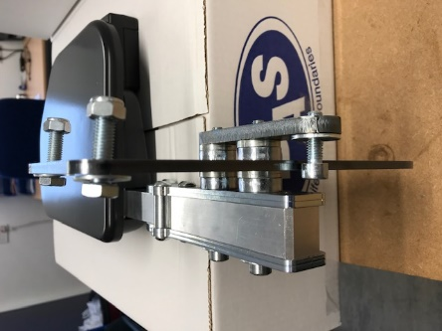
Spacers

Check mounting plate for any excess flexing or movement. If all is ok re fit trim cutting as required.
WE RECOMMEND THE USE OF LOCTITE ON ALL FIXING BOLTS
Please check all bolts for tightness before completing handover.

